Department of education and science of Ukraine

National technical university of Ukraine

«Kyiv polytechnic institute the name of Igor Sikorsky»

Faculty of informatics and computing engineering

Department of the computing engineering

Laboratory work №1

Discipline: «The algorithms theory»

Topic: «Decomposition method. Search for inversions»

EXECUTED:

The first-year student

of FICT group IP-95

*Guskov Danil*

The Student book number- 9505

CHECKED:

Associate Professor

The Computer Engineering Department

PhD, SR

Antoniuk A.I.

Kyiv - 2020

**TASK**

**Goal:**

Use the decomposition method to develop an algorithm and find the number of degrees of liking (number of inversions).

**Task variant: 5**

Develop an algorithm that will solve the following problem.

Incoming data. Matrix D of natural numbers of dimension um, where u is the number of users, m is the number of films. Each element of the matrix D [i, j] indicates the position of the movie j in the list of user preferences i. Another input is the x number of the user, which will be compared with the numbers of all other users.

Output data. List of ascending second element of pairs (i, c), where i is the user number, c is a number indicating the degree of similarity of the users' preferences x and c (number of inversions).

**SOFTWARE CODE**

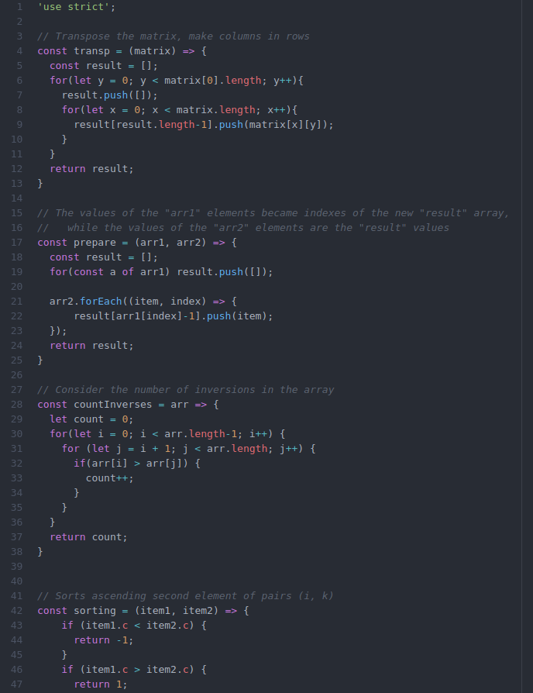

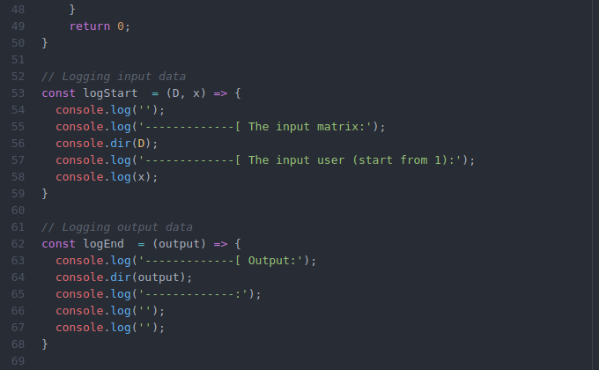

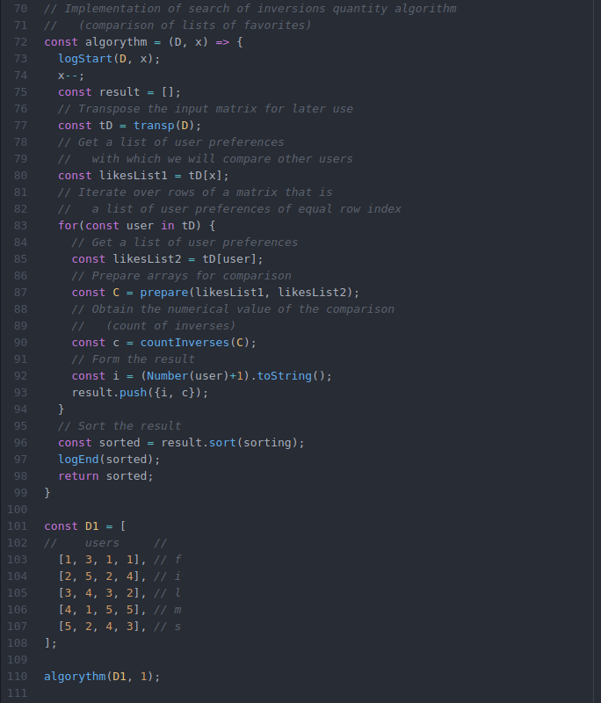

**RESULTS OF THE PROGRAM WORK**

The input: 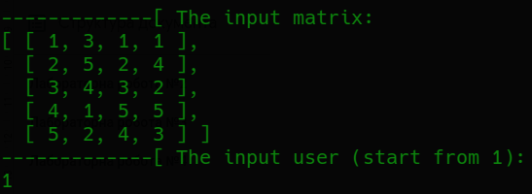

Output: 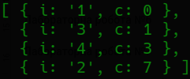

**CONCLUSIONS**

Familiarized with the topic of laboratory work.

Have acquired relevant work skills.

An appropriate test program has been developed.

The results of the successful work of the test program above confirm the correctness of the chosen decisions, the ultimate goal of the work has been achieved.